**Body Charts**

The chart below is a useful and simple way of recording injuries as an aid to later diagnosis. It is better to record what is actually observed than to speculate on the cause of the injuries at this stage.

If the body chart is to serve as a monitoring tool for minor injuries observed over a period of weeks (or even months), **a new body chart should be used on each occasion.** It is therefore very important to be consistent in the method of recording injuries so that comparisons can be made with earlier charts. **Where several different staff may be completing the monitoring forms, managers should ensure they understand what is required of them.**

The following points should be covered:

* Describe any marks, swelling, lacerations or other injuries carefully (cuts, bruises scratches)
* Describe the colour (brown/yellow/blue), size and shape of any bruises and indicate their location on the body chart; also describe any pattern if there are several bruises close together
* Briefly list any relevant circumstances witnessed, such as anger or aggression by vulnerable adult or by anyone in contact with the vulnerable adult
* Also record any explanations of injuries given immediately by the vulnerable adult and any other witnesses
* Ensure that for each chart completed the date and time of examination are clearly entered along with the name of the person completing the chart.

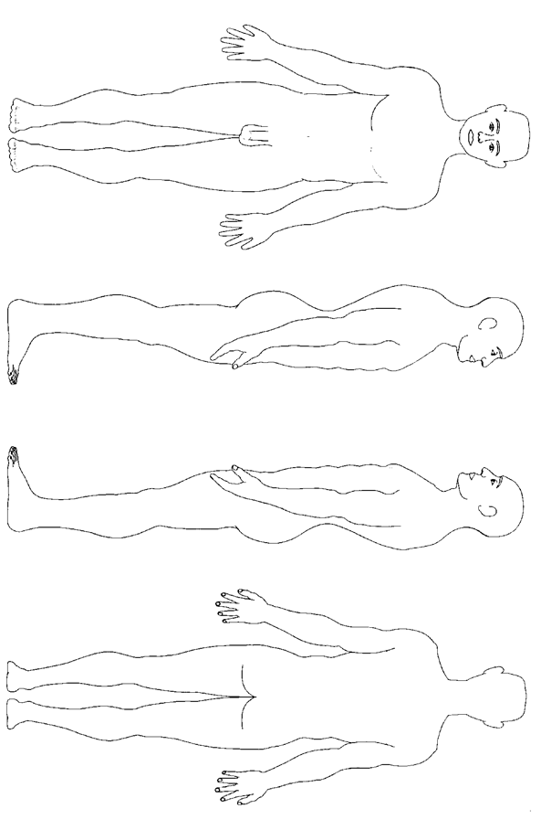

**Body Chart Male**

Please describe any marks you make on the chart e.g. cut, bite, bruise (and whether yellow or blue etc.)

Completed by: Date and time:

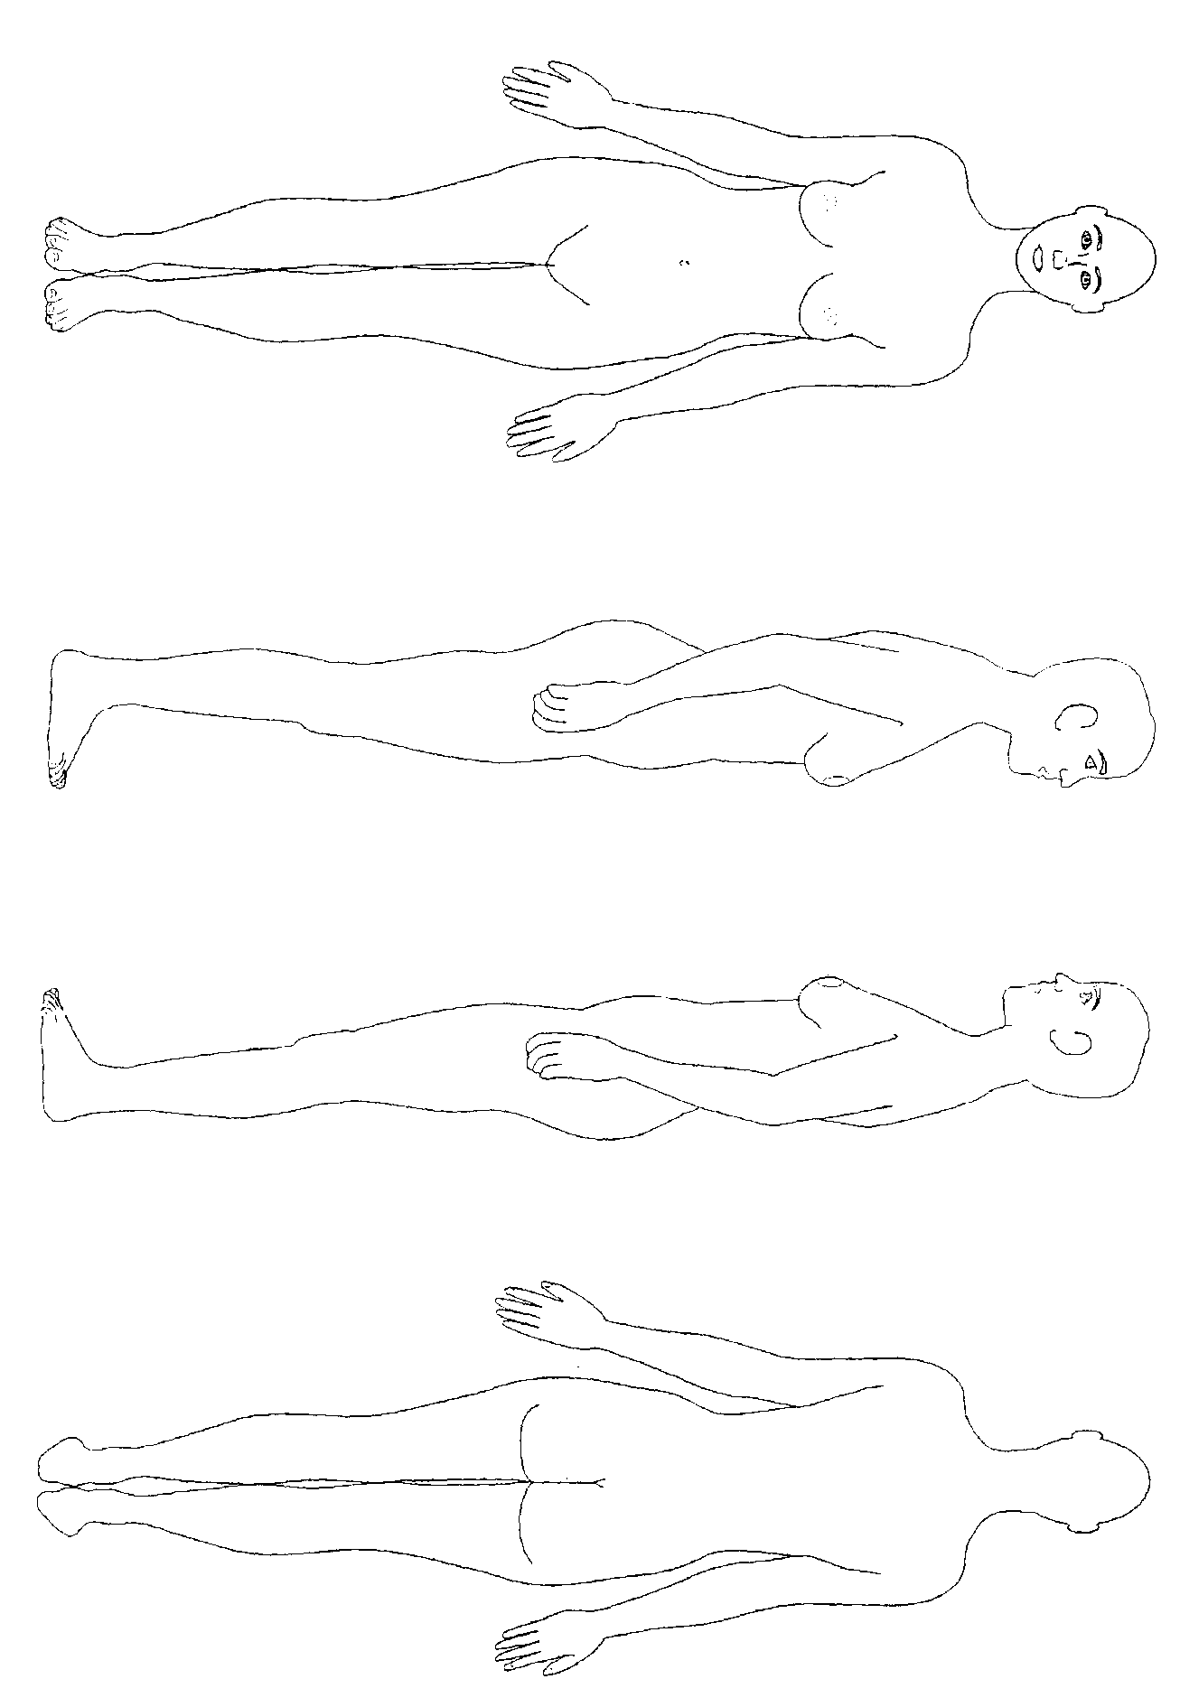

**Body Chart - Female**

Please describe any marks you make on the chart e.g. cut, bite, bruise (and whether yellow or blue etc.)

Completed by: Date and time: